Part 2: Distributed Implementation
2.1 Functionality
We have done the parallel part first before we doing Distributed part, so distributed part idea is base on Parallel part. It support all functionality in parallel part, Include SDL live view.
2.2 Final design
Our final design centers on a single broker process with Go RPC that clients dial to start runs (Broker.Run), stream turn data, and inject control events (Broker.Handlekey). The broker tracks all worker servers (each on its own AWS node) via Broker.Register, partitions the board dynamically, and only ever initiates RPC calls outbound to those workers, so the worker fleet stays private yet elastic: any worker that dials in is enrolled, and dead entries are pruned mid-turn with work automatically reissued. Each worker in turn spins up its own pool of logic goroutines to execute the row ranges assigned by the broker, returning flip sets that the broker aggregates and relays to the client over a dedicated TCP stream. Keyboard events are buffered before runs start and funneled through a broker-managed channel while the run is live, allowing p,s,q… without disrupting the streaming connection . Because every interaction happens through the broker’s static IP (RPC for control, TCP for streaming).
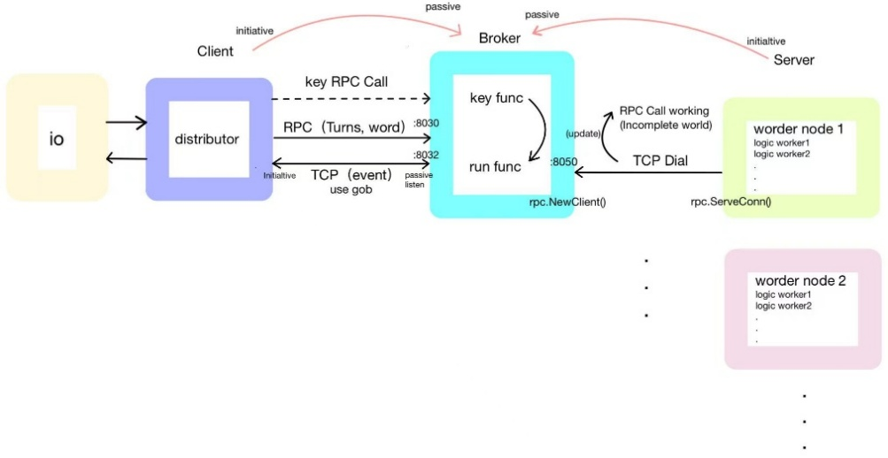
2.3 Special design&Advantage
High Fault Tolerance
The broker tracks every worker via Broker.Register, pings them each turn, and reruns the current turn if any RPC call fails.
- Dead workers are removed from WorkerAddr and their rows are immediately redistributed, so a single node failure never crashes the job
- New add workers will be notice by broker but it won’t affect current running test, it will apply to next test without crashing
Full World Transfer Only Once Between worker and broker
- The distributor pushes the full board to the broker only at the start of Broker.Run. From turn 2 onward, every RPC from the broker to workers includes just the current thisList (the complete set of candidate cells for that turn) plus it assigned dealing region with minimal halo rows they need for neighbor lookups, and every message back to t he client carries only CellsFlipped
Persistent TCP Stream
- Besides the RPC control channel, the broker keeps a long-lived TCP connection (streamListener) to the distributor for TURN/ALIVE/FINAL events. This avoids per-turn handshakes, lets AliveCellsCount updates go out every two seconds as required, and ensures keypress responses travel over the same reliable stream without loss.
Scalable Worker Pool
- The worker list is open-ended: any server that dials Broker.Register joins the pool, and the broker’s allocatethreadtoworker routine repartitions threads every time a run starts or a worker disappears. Spinning up more AWS nodes automatically shortens each turn because the broker will spread rows across the larger pool.
One connection between Broker and server
- Because each worker dials the broker proactively, it doesn’t need to expose any port; once the connection is established, keeping that single TCP link for all RPC traffic avoids repeated handshakes and saves both latency and resources.

Test Result and Benchmark
All tests successfully passed with the race detector enabled.
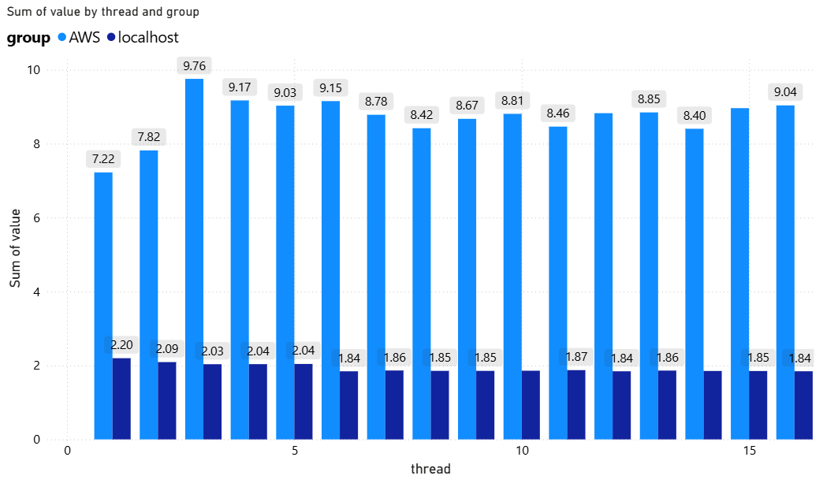
Testing was conducted independently on both a Lab machine local host and an AWS t3.micro instance. The distributed system demonstrated significantly slower performance compared to the local system, primarily due to:
- The overhead associated with remote communication, which exceeded the computational advantages of parallelism.
- The substantial impact of network instability on benchmark performance.
These findings underscore a critical insight in systems engineering: distributed computing does not inherently guarantee faster performance. Rather, performance is heavily influenced by network overhead and the granularity of the workload.
3. Conclusion
This course gives students a good opportunity to understand how concurrency and distributed systems behave in practice, beyond their theoretical advantages. Through implementing both the parallel and distributed versions of the Game of Life, we learned that performance is determined not only by algorithms, but also by coordination overhead, workload size, and the cost of communication.
Our parallel design achieved strong results on larger grids, where dynamic flip-cell tracking and efficient neighbour propagation provided enough computation to offset goroutine and merging overheads. However, when the number of active cells per turn was small, the fixed coordination cost limited scalability.
The distributed implementation highlighted even clearer trade-offs. Although our broker–worker architecture was fault-tolerant and scalable, remote execution on AWS was significantly slower than local execution due to RPC latency, network variability, and low per-turn workload.
Overall, the coursework demonstrated that effective system design requires balancing parallelism, communication, and computational granularity.

